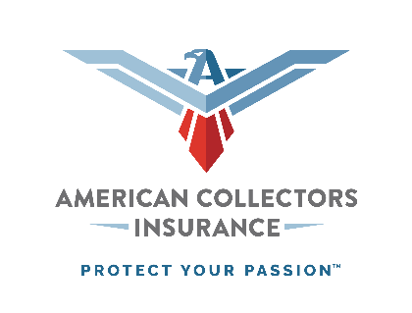

Since 1976, American Collectors Insurance has been serving the unique needs of classic and collector car owners across the country. We pride ourselves on being in touch with what’s important to owners — whether that’s Agreed Value coverage, expert claims handling, or competitive rates that are significantly less than standard auto. Our mission to embrace, protect and expand the collector community has not only created strong customer loyalty, but it has also made us the nation’s leading provider of collector vehicle and collectibles insurance.

Other things about American Collectors Insurance that you need to know!

- Our new TreasureGuardTM policy includes numerous policy enhancements (included at no additional cost) such as: $0 deductible on glass claims, $50 Basic Towing Reimbursement Coverage, $150 Personal Effects Coverage, $250 Disaster Relocation Expense Coverage, $500 Spare Parts Coverage, $750 Pet Coverage plus more!
- Customer Rankings: American Collectors Insurance is the highest-rated classic/collector car insurer in all major customer ratings providers (e.g., Trustpilot, Facebook, Google Reviews).
- Customer Service Availability: Extended customer service hours (8:00 am – 8:00 pm Mon-Fri, 8:00 am – 5:00 pm Sat, Eastern Time).
- More than Insurance: American Collectors Insurance provides more than insurance. We also offer free online resources for the collector car community, created by enthusiasts for enthusiasts, including: educational materials, contests, social media, video/article content for the classic/collector car hobby, and much more.

For more information or to become a partner, email brokerupdates@americancollectors.com or call 800.257.5758.

